**PROJECT REPORT FOR CYBER SECURITY ANALYTICS**

1. **INTRODUCTION:**

|  |  |
| --- | --- |
| Date | 10th March 2025 |
| Team ID | 1.05 |
| Project Name | Exploring Cyber Security - Understanding Threats and Solutions in the Digital Age |
| Maximum Marks | 1. Marks |

**1.1 LIST OF TEAMMATES:**

|  |  |  |  |
| --- | --- | --- | --- |
| **Sr.No** | **Name** | **College** | **Contact** |
| 1 | Chaitanya Satoke | SVPCET, Nagpur | chaitanyasatoke36@gmail.com |
| 2 | Sneh Nagpure | SVPCET, Nagpur | Nagpuresneh9960@gmail.com |
| 3 | Ayush Yerpude | SVPCET, Nagpur | yerpudeayush664@gmail.com |
| 4 | Atharva Shete | SVPCET, Nagpur | atharvashete15@gmail.com |

**1.2 ABSTRACT:**

Cybersecurity is a fundamental pillar of digital infrastructure, safeguarding individuals, businesses, and organizations against an ever-evolving landscape of cyber threats. This project explores various attack vectors, including malware, phishing, ransomware, and insider threats, while also delving into proactive defense mechanisms such as access controls, encryption, intrusion detection, and threat intelligence.

Through practical vulnerability assessments, Nessus scanning, and an in-depth study of SOC and SIEM frameworks, this project provides a comprehensive understanding of modern cybersecurity practices. Additionally, it highlights the human factor in cybersecurity, emphasizing awareness, training, and organizational resilience.

Emerging technologies such as IoT, cloud computing, and AI are also analyzed for their cybersecurity implications, ensuring readers grasp both present challenges and future developments.

**1.3 SCOPE OF THE PROJECT:**

* Understanding Digital Threats: Study of malware, phishing, ransomware, insider threats, and zero-day vulnerabilities.
* Web Security Testing: Identifying and mitigating security risks in a practice website.
* Automated Vulnerability Scanning: Using Nessus to assess security gaps.
* Defensive Strategies: Implementation of access control, encryption, firewalls, IDS/IPS, and threat intelligence.
* Security Operations (SOC & SIEM): Exploring security event monitoring and incident response frameworks.
* Application in College Environments: Assessing campus network security and integrating cybersecurity best practices.
  1. **OBJECTIVES OF THE PROJECT:**
* Analyze and classify different cyber threats and their impact.
* Perform practical web vulnerability testing to understand security flaws.
* Use Nessus for automated scanning and vulnerability assessment.
* Explore SOC and SIEM frameworks for enterprise security monitoring.
* Assess cybersecurity challenges in college environments and suggest solutions.
* Examine cybersecurity implications of emerging technologies like IoT, AI, and cloud computing.

**2.** **IDEATION PHASE**

**2.1 THE THOUGHT BEHIND THE PROJECT**

**Various Ideas of Teammates:**

**Ayush Yerpude**

**Atharva Shete**

**Chaitanya Satoke**

**Sneh Nagpure**

Investigating cybersecurity challenges in educational institutions.

Exploring SOC, SIEM, and Threat Intelligence platforms.

Performing Nessus scans to analyze security flaws.

Studying real-world cyberattacks and data breaches.

Identifying and testing web application vulnerabilities.ilities.

**2.2 FEATURES**

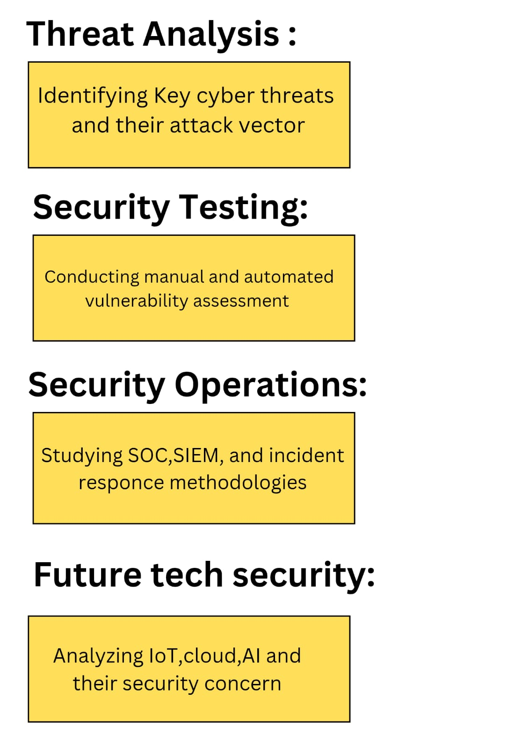

* 1. **PRIORITY CHART:**

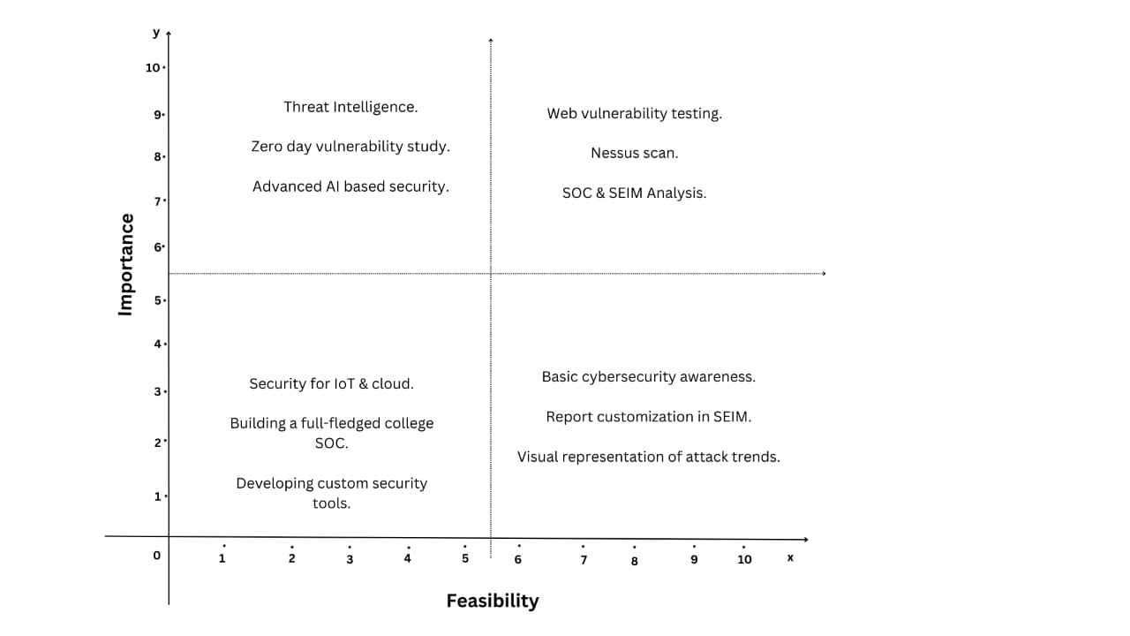

**2.****4 EMPATHY MAP:**

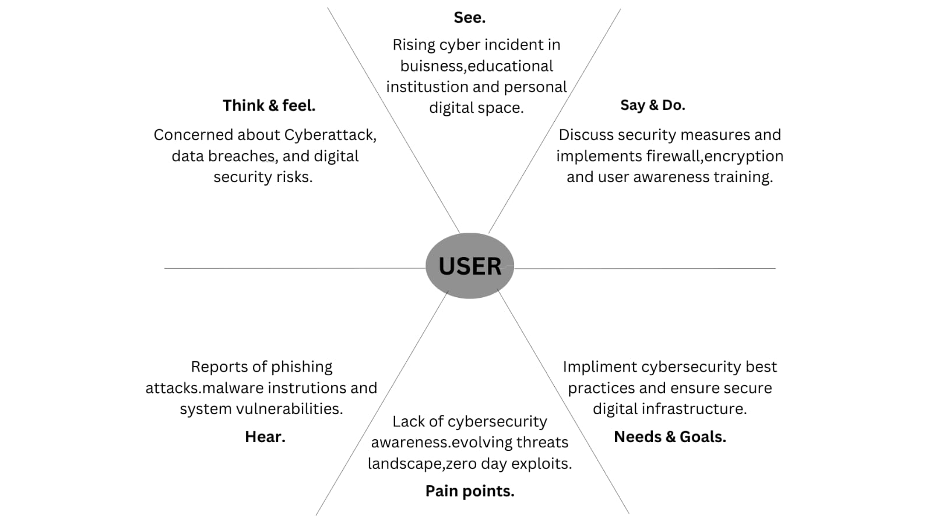

1. **REQUIREMENT ANALYSIS:**

**3.1 LIST OF VULNERABILITIES**

|  |  |  |
| --- | --- | --- |
| **Sr.No** | **Vulnerability Name** | **CWE No.** |
| 1 | SQL Injection | CWE-89 |
| 2 | Cross-Site Scripting (XSS) | CWE-79 |
| 3 | Command Injection | CWE-78 |
| 4 | CSRF (Cross-Site Request Forgery) | CWE-352 |
| 5 | Broken Authentication | CWE-287 |

**Report**

**1. Vulnerability Name: SQL Injection**

* **CWE:** CWE-89
* **OWASP/SANS Category:** Injection Attacks
* **Description:**  
  SQL Injection allows attackers to manipulate *SQL queries* by injecting malicious input into a website’s database query. This can lead to *data theft, unauthorized access, or database manipulation.*
* **Business Impact:**
  + Unauthorized access to sensitive user data.
  + Potential *data breaches and loss of integrity*.
  + Could lead to *complete database compromise.*
* **Steps Followed:**
  + - Open *DVWA* and set security level to *low*.
    - Navigate to *SQL Injection* module.
    - Enter 1' OR '1'='1 in the input field and submit.
    - Observe that all user records are displayed, proving SQL Injection vulnerability.

**2. Vulnerability Name: Cross-Site Scripting (XSS)**

* **CWE:** CWE-79
* **OWASP/SANS Category:** Cross-Site Scripting (XSS)
* **Description:**  
  XSS occurs when an attacker injects *malicious JavaScript* into a website, which is then executed in a victim’s browser. This can result in *cookie theft, session hijacking, and defacement attacks.*
* **Business Impact:**
  + Attackers can *steal user credentials*.
  + Can be used for *phishing attacks* and spreading malware.
  + Loss of *trust and credibility* for the website.
* **Steps Followed:**
  + - Navigate to *DVWA XSS (Stored)* module.
    - Input <script>alert("XSS Attack!")</script> in the form field.
    - Submit the form and refresh the page.
    - The JavaScript alert pops up, confirming the vulnerability.

**3. Vulnerability Name: Command Injection**

* **CWE:** CWE-78
* **OWASP/SANS Category:** Injection Attacks
* **Description:**  
  Command Injection occurs when an attacker *injects system commands* into a vulnerable application. The application then executes these commands with the privileges of the web server, leading to *system compromise*.
* **Business Impact:**
  + Attackers can *execute arbitrary system commands.*
  + Can result in *data leaks, privilege escalation, or full server takeover.*
  + High risk for *critical infrastructure and sensitive data.*
* **Steps Followed:**
  + - Open the *Command Execution* module in DVWA.
    - Enter 127.0.0.1; ls in the input field and submit.
    - Observe that the command *lists directory contents*, confirming the vulnerability.

**4. Vulnerability Name: Cross-Site Request Forgery (CSRF)**

* **CWE:** CWE-352
* **OWASP/SANS Category:** Security Misconfiguration
* **Description:**  
  CSRF allows an attacker to *trick a logged-in user into performing an unwanted action* (e.g., changing a password) by exploiting session cookies and lack of CSRF protection.
* **Business Impact:**
  + Attackers can *modify user account settings without permission.*
  + Can result in *privilege escalation or account takeovers.*
  + Reduces trust in the platform's *security mechanisms.*
* **Steps Followed:**
  + - Log in to *DVWA* with admin credentials.
    - Capture the *password change request* in Burp Suite.
    - Craft a malicious HTML form that submits a password change request.
    - Trick the logged-in user into visiting the malicious page.
    - The attacker successfully changes the victim’s password.

**5. Vulnerability Name: Broken Authentication**

* **CWE:** CWE-287
* **OWASP/SANS Category:** Authentication & Session Management
* **Description:**  
  Broken authentication occurs when *password management mechanisms are weak*, allowing attackers to brute-force accounts or reuse stolen credentials.
* **Business Impact:**
  + Allows attackers to *gain unauthorized access to user accounts.*
  + Can lead to *data theft and account hijacking*.
  + Increases risk of *credential stuffing attacks*.
* **Steps Followed:**
  + - Open the *DVWA Login Page.*
    - Attempt *default admin credentials (admin:password).*
    - Successfully log in, indicating weak authentication security.

**3.2 SOLUTION REQUIREMENT (VULNERABILITY ASSESSMENT DETAILS):**

**1. SQL Injection (CWE-89) - Solution Requirement**

* **Input Validation & Parameterized Queries:** Use **prepared statements** or **ORM frameworks** to prevent malicious SQL queries.
* **Stored Procedures:** Implement **stored procedures** to separate SQL logic from user inputs.
* **Least Privilege Access:** Restrict database access for application users to **prevent unauthorized modifications**.
* **Web Application Firewall (WAF):** Deploy **WAFs like ModSecurity** to filter malicious SQL patterns.
* **Regular Security Audits:** Conduct **routine database security assessments** to detect vulnerabilities.

**2. Cross-Site Scripting (XSS) (CWE-79) - Solution Requirement**

* **Input Sanitization & Output Encoding:** Implement **HTML escaping** (e.g., using htmlspecialchars() in PHP) to prevent script execution.
* **Content Security Policy (CSP):** Configure **CSP headers** to block execution of untrusted scripts.
* **Secure Cookie Attributes:** Use **HttpOnly and Secure** flags on cookies to prevent theft via XSS.
* **User Input Validation:** Restrict input fields to **expected values** (e.g., alphanumeric, specific formats).
* **Regular Penetration Testing:** Perform **frequent security testing** to identify new XSS attack vectors.

**3. Command Injection (CWE-78) - Solution Requirement**

* **Input Whitelisting & Validation:** Restrict user input to **expected values only** (e.g., IP addresses in a ping utility).
* **Use of Secure APIs:** Replace **direct system calls** with secure API functions that do not allow command execution.
* **Least Privilege Execution:** Run web applications with **restricted OS-level permissions** to limit command execution risks.
* **Disabling Unnecessary System Calls:** Restrict execution of **dangerous system commands** (e.g., exec(), system(), shell_exec() in PHP).
* **Logging & Monitoring:** Enable **system command execution logs** to detect unauthorized access attempts.

**4. Cross-Site Request Forgery (CSRF) (CWE-352) - Solution Requirement**

* **CSRF Tokens:** Implement **unique, per-session CSRF tokens** in requests that modify user data.
* **SameSite Cookie Attribute:** Use **SameSite=strict** or **SameSite=lax** to prevent CSRF attacks via cross-origin requests.
* **User Authentication for Sensitive Actions:** Require users to **re-authenticate before making security-sensitive changes**.
* **Referrer Validation:** Check **HTTP referrer headers** to ensure requests originate from trusted sources.
* **Multi-Factor Authentication (MFA):** Implement **MFA** to prevent unauthorized transactions caused by CSRF attacks.

**5. Broken Authentication (CWE-287) - Solution Requirement**

* **Enforce Strong Password Policies:** Require **minimum password length, complexity, and expiration policies**.
* **Multi-Factor Authentication (MFA):** Implement **OTP-based or biometric authentication** for critical actions.
* **Session Management Best Practices:**
  + Set **session timeout limits**.
  + Use **Secure and HttpOnly cookies** to prevent session hijacking.
  + Implement **automatic logout for inactive sessions**.
* **Account Lockout Mechanisms:** Block access after **multiple failed login attempts** to prevent brute-force attacks.
* **Implement OAuth & Secure Authentication Protocols:** Use **OAuth 2.0, OpenID Connect, or SAML** for secure authentication.
  1. **TECHNOLOGY STACK (TOOLS EXPLORED):**

1. **DVWA (Damn Vulnerable Web Application)** – A deliberately vulnerable web application used for *manual penetration testing*.
2. **Burp Suite** – A powerful tool for *intercepting and analyzing web requests*, commonly used for *SQL Injection, XSS, and CSRF testing*.
3. **OWASP ZAP** – An automated vulnerability scanner used to *identify security weaknesses, misconfigurations, and outdated software.*
4. **Kali Linux** – A penetration testing distribution containing *various cybersecurity tools for ethical hacking and security research.*
5. **PROJECT DESIGN:**

**4.1** **OVERVIEW OF ZAP:**

In this stage, we aimed to conduct an automated vulnerability scan to identify security weaknesses in DVWA (Damn Vulnerable Web Application). Initially, we planned to use Nessus, but due to setup issues, we switched to OWASP ZAP (Zed Attack Proxy), a widely used security tool for scanning web applications.

From our research on Nessus, we understood that it is primarily used for network vulnerability scanning, identifying misconfigurations, weak passwords, and outdated software versions. Unlike manual penetration testing, Nessus provides automated risk assessment, prioritizing vulnerabilities based on severity. However, OWASP ZAP is better suited for web application security testing, focusing on issues like injection attacks, session security, and authentication flaws.

Through OWASP ZAP scanning, we discovered multiple vulnerabilities in DVWA, categorized as High, Medium, and Low risk. The scanning process involved crawling the web application, intercepting HTTP requests, and analyzing responses for security weaknesses. The results from ZAP provided valuable insights into potential attack vectors and recommended mitigation strategies.

**4.2** **PROPOSED SOLUTION:**

During this project, we conducted *manual and automated vulnerability assessments* on *DVWA (Damn Vulnerable Web Application)* to identify security flaws that could be exploited by attackers. Using *OWASP ZAP*, we scanned the application and discovered *15 critical vulnerabilities*, including *SQL Injection, Cross-Site Scripting (XSS), Remote Code Execution, CSRF, and Directory Traversal.* These findings highlighted weaknesses in *input validation, authentication mechanisms, session management, and web security configurations.*

To mitigate these security risks, we propose a *multi-layered security approach* that addresses both *application-level weaknesses and infrastructure security.*

**1. Secure Development Practices Based on Findings**

**Findings:** Many vulnerabilities, such as *SQL Injection and XSS*, exist due to *improper input validation and lack of output encoding.*

**Proposed Solution:**

* Implement *input validation and sanitization* to prevent *injection attacks*.
* Use *parameterized queries and ORM frameworks* to eliminate SQL Injection.
* Escape user input using **output encoding libraries (e.g., HTML escaping for XSS prevention)**.
* Conduct *secure code reviews* and implement *static application security testing (SAST) tools* to detect security flaws early in development.

**2. Authentication and Access Control Improvements**

**Findings:** The assessment revealed *weak authentication mechanisms and lack of rate-limiting on login pages*, making the application vulnerable to *brute-force attacks and session hijacking.*

**Proposed Solution:**

* Enforce *strong password policies* (minimum length, complexity requirements, and expiration policies).
* Implement *Multi-Factor Authentication (MFA)* to prevent unauthorized access.
* Introduce *account lockout mechanisms to prevent brute-force attacks.*
* Secure session management by enabling *HttpOnly, Secure, and SameSite cookie attributes to prevent session hijacking and CSRF attacks*.

**3. Automated Vulnerability Scanning and Security Monitoring**

**Findings:** The *manual vulnerability scanning process was time-consuming*, and certain vulnerabilities like *insecure headers and directory browsing* were identified only through *OWASP ZAP’s automated scan.*

**Proposed Solution:**

* Integrate *automated vulnerability scanning tools like OWASP ZAP, Nessus, and Burp Suite* into the security assessment process.
* Use *SIEM (Security Information and Event Management) systems* to monitor *security events in real-time* and detect anomalies.
* Implement *continuous security monitoring and automated alerting mechanisms* to respond to potential threats proactively.

**4. Strengthening Security Headers and Web Server Configurations**

**Findings:** Our testing identified *missing security headers*, such as *Content Security Policy (CSP), X-Frame-Options, and HSTS*, which made the application vulnerable to *Clickjacking and XSS attacks.*

**Proposed Solution:**

* Enforce *HTTP security headers*, including:
  + **X-Frame-Options: DENY** (Prevents Clickjacking)
  + **Content-Security-Policy (CSP): Default-src ‘self’** (Mitigates XSS)
  + **Strict-Transport-Security (HSTS)** (Forces HTTPS usage)
  + **X-Content-Type-Options: nosniff** (Prevents MIME sniffing attacks)
* Disable *directory listing and unnecessary HTTP methods* to prevent information disclosure.
* Regularly audit and update *server configurations to harden security.*

**5. Mitigation of CSRF and Session Hijacking Risks**

**Findings:** The *absence of anti-CSRF tokens* and the *lack of SameSite cookie attributes* exposed users to *Cross-Site Request Forgery (CSRF) attacks.*

**Proposed Solution:**

* Implement *CSRF protection tokens in all state-changing requests*.
* Use *SameSite=strict* attributes on cookies to *prevent cross-origin request manipulation.*
* Require *user re-authentication before performing sensitive actions.*
* Deploy *secure session expiration policies* and automatic logouts for inactive users.

**6. Enhancing Web Application Firewall (WAF) & Intrusion Detection**

**Findings:** The application lacked *defensive mechanisms* against *common web-based attacks*, making it easy to exploit vulnerabilities like *SQL Injection, XSS, and Remote**Code Execution.*

**Proposed Solution:**

* Deploy a *Web Application Firewall (WAF)* to *filter malicious requests and block automated attacks.*
* Implement *Intrusion Detection and Prevention Systems (IDS/IPS)* to monitor *suspicious network activity.*
* Log and analyze *failed login attempts, unusual user behavior, and system vulnerabilitie***s** through a *centralized security dashboard*.

**7. Regular Patch Management and Security Updates**

**Findings:** The vulnerability scan revealed **outdated software versions** in the DVWA environment, increasing the risk of *exploiting known vulnerabilities*.

**Proposed Solution:**

* Regularly update and *patch all software components* (web frameworks, libraries, database systems, and operating systems).
* Implement *automated patch management* to prevent vulnerabilities caused by outdated dependencies.
* Remove *unused or deprecated plugins and scripts* that could introduce security risks.

**8. Security Awareness and Training for Users**

**Findings:** While *technical solutions* address most vulnerabilities, human errors (e.g., weak passwords, phishing susceptibility) remain a significant risk factor.

**Proposed Solution:**

* Conduct *regular cybersecurity awareness training* for developers, administrators, and end-users.
* Implement *phishing simulations and security drills* to educate users on *social engineering threats.*
* Develop a *security best practices guide* for handling sensitive data and recognizing cyber threats.

**9. Incident Response and Disaster Recovery Planning**

**Findings:** Our assessment showed that there were *no defined response measures in case of an attack or system compromise.*

**Proposed Solution:**

* Establish a *Cyber Incident Response Team (CIRT)* to handle security breaches.
* Implement *incident detection and logging systems* to track *attack patterns and threat intelligence.*
* Develop a *disaster recovery strategy*, including *regular backups, failover mechanisms, and cloud-based security solutions.*

**4.3 UNDERSTANDING OF Exploring Cyber Security - Understanding Threats and Solutions in the Digital Age:**

**1. Malware and Its Evolving Threat Landscape**

Malware, or malicious software, is a persistent cybersecurity threat that includes viruses, worms, Trojans, and ransomware. Attackers use malware to steal data, damage systems, or gain unauthorized access. With the rise of AI-driven malware and fileless attacks, organizations must continuously evolve their security strategies, incorporating endpoint protection, behavioral analysis, and real-time threat intelligence to mitigate risks effectively.

**2. Phishing Attacks: Techniques and Prevention**

Phishing is a social engineering attack that tricks individuals into revealing sensitive information such as login credentials and banking details. Modern phishing techniques, like spear phishing and whaling, target specific individuals or high-ranking executives. Organizations must implement email security protocols (SPF, DKIM, DMARC), conduct regular employee awareness training, and use AI-based email filtering to reduce phishing attempts.

**3. Ransomware: A Growing Cyber Extortion Threat**

Ransomware encrypts victims' files and demands payment for decryption keys. High-profile attacks on corporations and healthcare institutions highlight its devastating impact. Preventing ransomware requires proactive security measures such as regular backups, network segmentation, and zero-trust architectures. Security frameworks like MITRE ATT&CK provide valuable insights into ransomware tactics and techniques for effective defense strategies.

**4. The Role of AI and Machine Learning in Cybersecurity**

AI and machine learning are transforming cybersecurity by improving threat detection and response. These technologies analyze vast datasets to identify anomalies, detect zero-day threats, and automate incident response. However, cybercriminals also exploit AI to create deepfake scams and automate attacks. Ethical AI development and adversarial machine learning research are crucial to countering these threats.

**5. The Human Factor in Cybersecurity: Social Engineering Risks**

Despite advanced security technologies, human error remains a primary vulnerability. Social engineering attacks manipulate human psychology to bypass security defenses. Common techniques include pretexting, baiting, and tailgating. Organizations must foster a strong cybersecurity culture through continuous education, implementing strict access controls, and reinforcing policies like multi-factor authentication (MFA).

**6. IoT Security: Risks and Defense Mechanisms**

The Internet of Things (IoT) has expanded attack surfaces, with devices like smart cameras, medical equipment, and industrial sensors becoming prime targets. Weak authentication, outdated firmware, and lack of encryption expose IoT devices to cyber threats. Security measures like network segmentation, strong authentication protocols, and device monitoring are crucial for securing IoT ecosystems.

**7. Enhancing Cybersecurity Awareness and Resilience in Our College Environment**

Our project, ***"****Exploring Cyber Security: Understanding Threats and Solutions in the Digital Age"* can be implemented in our college environment to *promote cybersecurity awareness and strengthen digital security practices* among students, faculty, and staff. Many individuals in academic institutions lack awareness of cyber threats like phishing, password breaches, and social engineering, making them vulnerable targets.

To address this, we can conduct *cybersecurity awareness workshops, phishing simulation campaigns, and hands-on training sessions* to educate students and faculty on best security practices. Additionally, our research findings can be used to create *informational posters, newsletters, and interactive sessions* focusing on password hygiene, multi-factor authentication (MFA), secure browsing habits, and ethical hacking.

This initiative will not only *benefit our institution by reducing cyber risks* but also *prepare students for careers in cybersecurity* by equipping them with practical knowledge and real-world security skills.

**8. Cybersecurity in the Education Sector: Risks and Mitigation**

Educational institutions store vast amounts of sensitive student and faculty data, making them prime targets for cyberattacks. Phishing, ransomware, and data breaches are common threats in academic environments. Schools and universities must adopt cybersecurity policies, conduct regular awareness training, and enforce access controls to prevent unauthorized data access and safeguard online learning platforms.

**9. Cyber Laws and Ethical Hacking: Legal Frameworks and Responsibilities**

Cybersecurity is not just about defense but also compliance with global and national laws. Regulations such as GDPR, CCPA, and India's IT Act govern data protection and privacy. Ethical hacking plays a crucial role in identifying vulnerabilities legally. Understanding the ethical, legal, and regulatory landscape is essential for cybersecurity professionals to ensure compliance while conducting security assessments.

**10. Future Trends in Cybersecurity: Preparing for the Next Decade**

Cyber threats continue to evolve, and future challenges include quantum computing threats, AI-powered attacks, and cyber warfare. Organizations need to invest in post-quantum cryptography, enhance security automation, and develop advanced threat intelligence capabilities. Collaboration between governments, cybersecurity experts, and industries is essential to staying ahead of emerging threats and ensuring global digital security.

**11. Cloud Security Challenges and Best Practices**

With businesses increasingly relying on cloud services, securing cloud environments is critical. Misconfigured cloud storage, weak identity management, and API vulnerabilities are major risks. Best practices for cloud security include implementing robust identity and access management (IAM), conducting regular security audits, and following compliance standards such as ISO 27001 and NIST CSF to safeguard sensitive data.

1. **PROJECT PLANNING AND SCHEDULING**

**5.1 PROJECT PLANNING:**

* **Product Backlog, Sprint Schedule, and Estimation (4 Marks)**

|  |  |  |  |  |  |  |
| --- | --- | --- | --- | --- | --- | --- |
| **Sprint** | **Functional Requirement (Epic)** | **User Story Number** | **User Story / Task** | **Story Points** | **Priority** | **Team Members** |
| Sprint-1 | Security Assessment | USN-1 | As a security analyst, I can perform a vulnerability scan using Nessus to identify risks. | 4 | High | Atharva Shete |
| Sprint-1 | Security Assessment | USN-2 | As an analyst, I can analyze the scan results and prioritize vulnerabilities. | 3 | High | Chaitanya Satoke |
| Sprint-2 | Threat Analysis & Research | USN-3 | As a cybersecurity researcher, I can study emerging cyber threats to document defensive measures. | 4 | High | Sneh Nagpure |
| Sprint-2 | Threat Analysis & Research | USN-4 | As a security analyst, I can map vulnerabilities found in our practice website to the MITRE ATT&CK framework. | 3 | Medium | Ayush Yerpude |
| Sprint-3 | Cybersecurity Awareness & Documentation | USN-5 | As a security consultant, I can write a report on cybersecurity measures applicable in a college environment. | 4 | High | Chaitanya Satoke |
| Sprint-3 | Cybersecurity Awareness & Documentation | USN-6 | As a researcher, I can analyze real-world case studies to provide recommendations for improved security practices. | 3 | Medium | Atharva Shete |

* **Project Tracker, Velocity & Burndown Chart (4 Marks)**

**Sprint Plan and Story Points**

|  |  |  |  |  |  |  |
| --- | --- | --- | --- | --- | --- | --- |
| **Sprint** | **Total Story Points** | **Duration** | **Sprint Start Date** | **Sprint End Date (Planned)** | **Story Points Completed (as on Planned End Date)** | **Sprint Release Date (Actual)** |
| Sprint-1 | 7 | 7 Days | 24 February 2025 | 02 March 2025 | - | - |
| Sprint-2 | 7 | 5 Days | 03 March 2025 | 07 March 2025 | - | - |
| Sprint-3 | 7 | 5 Days | 08 March 2025 | 12 March 2025 | - | - |

**Burndown Chart**

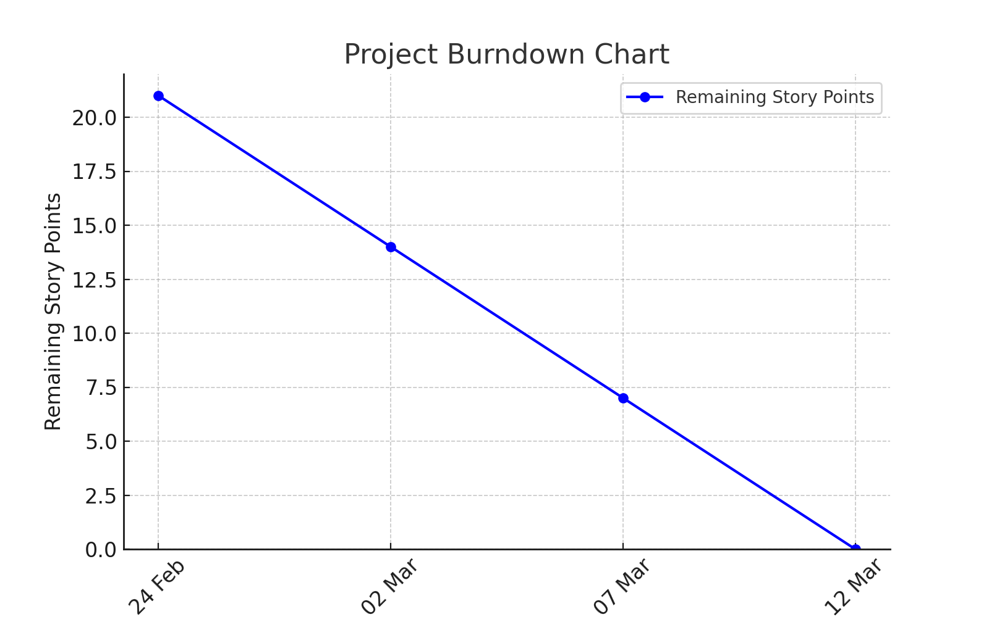

1. **FUNCTIONAL AND** **PERFORMANCE TESTING**

**Target Website & IP Address**

* **Target Website: DVWA (Damn Vulnerable Web Application)**
* **Target IP Address: 192.168.137.220**

**List of Vulnerabilities Table**

|  |  |  |  |
| --- | --- | --- | --- |
| **S.No** | **Vulnerability Name** | **Severity** | **Plugin/Reference** |
| **1** | Remote Code Execution (CVE-2012-1823) | High | OWASP_2017_A09 |
| **2** | Source Code Disclosure (CVE-2012-1823) | High | OWASP_2021_A06 |
| **3** | Absence of Anti-CSRF Tokens | Medium | WSTG-v42-INPV-12 |
| **4** | Content Security Policy (CSP) Not Set | Medium | OWASP_2021_A05 |
| **5** | Directory Browsing Enabled | Medium | OWASP_2021_A06 |
| **6** | Missing Anti-Clickjacking Header | Medium | OWASP_2021_A05 |
| **7** | Cookie Without HttpOnly Flag | Medium | OWASP_2021_A05 |
| **8** | Server Leaks Version Information via "X-Powered-By" Header | Low | WSTG-v42-INFO-02 |
| **9** | Cookie Without SameSite Attribute | Medium | OWASP_2021_A05 |
| **10** | Hidden File Found | Medium | OWASP_2021_A06 |
| **11** | Information Disclosure via phpinfo() | Medium | OWASP_2021_A06 |
| **12** | Directory Traversal | High | OWASP_2021_A01 |
| **13** | No Rate Limiting on Login Page | High | OWASP_2021_A02 |
| **14** | Missing Security Headers | Medium | OWASP_2021_A06 |
| **15** | Unvalidated Redirects & Forwards | Medium | OWASP_2021_A10 |

**Vulnerability Report Details**

**1. Vulnerability Name: Remote Code Execution (CVE-2012-1823)**

* **Severity:** High
* **Plugin:** OWASP_2017_A09
* **Port:** Web Application (HTTP)
* **Description:**Some PHP versions, when configured to run using CGI, do not correctly handle query strings, allowing arbitrary code execution. Attackers can exploit this vulnerability to execute system commands on the web server, leading to unauthorized access and potential system compromise.
* **Solution:** 
  + Upgrade to the latest stable PHP version.
  + Disable allow_url_include and auto_prepend_file in PHP configurations.
  + Use web application firewalls (WAFs) to filter out malicious request patterns.
* **Business Impact:** 
  + Attackers can execute arbitrary commands, leading to data breaches.
  + If exploited, this vulnerability can be used to escalate privileges and gain full control of the server.

**2. Vulnerability Name: Source Code Disclosure (CVE-2012-1823)**

* **Severity:** High
* **Plugin:** OWASP_2021_A06
* **Port:** Web Application (HTTP)
* **Description:**This vulnerability occurs due to misconfigured PHP CGI settings, which can expose source code through manipulated URL requests. If an attacker can access PHP files as plain text, they may discover database credentials, API keys, and internal logic.
* **Solution:** 
  + Disable exposing PHP errors in production environments.
  + Configure the server to handle .php files securely to prevent direct source code exposure.
  + Implement access control measures to restrict direct file access.
* **Business Impact:** 
  + Exposure of database credentials or API keys can lead to data theft.
  + Attackers can study application logic and create tailored exploits.

**3. Vulnerability Name: Absence of Anti-CSRF Tokens**

* **Severity:** Medium
* **Plugin:** WSTG-v42-INPV-12
* **Port:** Web Application (HTTP)
* **Description:**The application does not implement CSRF protection mechanisms, allowing attackers to trick authenticated users into performing unintended actions (e.g., changing passwords, modifying account details).
* **Solution:** 
  + Implement CSRF tokens in all state-changing requests.
  + Use the SameSite cookie attribute to prevent cross-origin request attacks.
  + Require re-authentication before performing sensitive actions.
* **Business Impact:** 
  + Attackers can manipulate user sessions, leading to unauthorized changes in accounts.
  + Could result in privilege escalation and account takeovers.

**4. Vulnerability Name: Content Security Policy (CSP) Not Set**

* **Severity:** Medium
* **Plugin:** OWASP_2021_A05
* **Port:** Web Application (HTTP)
* **Description:**The lack of a Content Security Policy (CSP) allows the execution of malicious scripts (such as XSS payloads). Without CSP, attackers can inject JavaScript into the website to steal user data, hijack sessions, or deface web pages**.**
* **Solution:** 
  + Implement a strong CSP header to restrict script execution from untrusted sources.
  + Use nonce-based or hash-based script validation**.**
  + Disable eval() and inline JavaScript execution in CSP settings**.**
* **Business Impact:** 
  + Affected users may face data theft, session hijacking, and browser exploitation.
  + Attackers can inject malicious JavaScript payloads, compromising website integrity.

**5. Vulnerability Name: Directory Browsing Enabled**

* **Severity:** Medium
* **Plugin:** OWASP_2021_A06
* **Port:** Web Application (HTTP)
* **Description:**Directory browsing is enabled on the server, allowing attackers to list all files in a directory. This can expose configuration files, backup files, and other sensitive resources that should not be accessible to users.
* **Solution:** 
  + Disable directory listing in Apache (.htaccess) or Nginx configurations.
  + Restrict access to internal directories using permission controls.
  + Remove any unnecessary backup or log files from public directories.
* **Business Impact:** 
  + Attackers can discover sensitive files, including database dumps and admin scripts.
  + Information leakage may lead to further attacks, such as path traversal or file inclusion exploits.

**6. Vulnerability Name: Missing Anti-Clickjacking Header**

* **Severity:** Medium
* **Plugin:** OWASP_2021_A05
* **Port:** Web Application (HTTP)
* **Description:**  
  The application does not set the *X-Frame-Options* or *Content Security Policy (CSP) frame-ancestors* headers, making it vulnerable to *clickjacking attacks*. Attackers can embed the website in a malicious page and trick users into performing unintended actions.
* **Solution:**
  + Implement *X-Frame-Options***:** *DENY* or *SAMEORIGIN* in HTTP headers.
  + Use *CSP frame-ancestors* to control allowed framing sources.
  + Regularly test for clickjacking vulnerabilities.
* **Business Impact:**
  + Attackers can *steal user interactions and manipulate actions.*
  + Can be used for *phishing attacks* or *session hijacking*.

**7. Vulnerability Name: Cookie Without HttpOnly Flag**

* **Severity:** Medium
* **Plugin:** OWASP_2021_A05
* **Port:** Web Application (HTTP)
* **Description:**  
  Cookies set by the application do not have the *HttpOnly* attribute enabled, making them accessible via JavaScript. This increases the risk of *session hijacking* through Cross-Site Scripting (XSS) attacks.
* **Solution:**
  + Set the *HttpOnly* flag for session cookies to *prevent client-side access*.
  + Enable *Secure* flag to ensure cookies are only sent over HTTPS.
  + Regularly audit session management policies.
* **Business Impact:**
  + Attackers can *steal session cookies* and impersonate users.
  + Can lead to *account takeovers and data breaches*.

**8. Vulnerability Name: Server Leaks Version Information via "X-Powered-By" Header**

* **Severity:** Low
* **Plugin:** WSTG-v42-INFO-02
* **Port:** Web Application (HTTP)
* **Description:**  
  The application *reveals technology stack details* (e.g., PHP, Apache version) via HTTP headers, which can help attackers *identify known vulnerabilities.*
* **Solution:**
  + Configure the server to *remove "X-Powered-By" and "Server" headers.*
  + Use *mod_headers in Apache* or *server_tokens off in Nginx* to hide version information.
  + Implement a *Web Application Firewall (WAF)* to filter information leakage.
* **Business Impact:**
  + Attackers can *use leaked information to target specific vulnerabilities*.
  + Increases *risk of automated attacks and reconnaissance-based exploits*.

**9. Vulnerability Name: Cookie Without SameSite Attribute**

* **Severity:** Medium
* **Plugin:** OWASP_2021_A05
* **Port:** Web Application (HTTP)
* **Description:**  
  The application sets cookies without specifying the *SameSite* attribute, making them vulnerable to *cross-site request forgery (CSRF) attacks.*
* **Solution:**
  + Set *SameSite=Strict or Lax* in cookies to prevent cross-site requests.
  + Implement *CSRF protection tokens* in state-changing requests.
  + Use *secure authentication mechanisms* like OAuth for session management.
* **Business Impact:**
  + Attackers can *trick users into performing unauthorized actions.*
  + Increases risk of *account hijacking through malicious third-party websites.*

**10. Vulnerability Name: Hidden File Found**

* **Severity:** Medium
* **Plugin:** OWASP_2021_A06
* **Port:** Web Application (HTTP)
* **Description:**  
  The scan detected *hidden files or backup files* that could *contain sensitive information*, such as configuration settings, credentials, or source code.
* **Solution:**
  + Remove *unnecessary backup files, logs, and configuration files* from the server.
  + Implement *proper file permissions* to restrict unauthorized access.
  + Disable *directory listing* to prevent attackers from enumerating files.
* **Business Impact:**
  + Attackers can *extract sensitive data* leading to *data breaches*.
  + Increases risk of *source code theft and infrastructure reconnaissance*.

**11. Vulnerability Name: Information Disclosure via phpinfo()**

* **Severity:** Medium
* **Plugin:** OWASP_2021_A06
* **Port:** Web Application (HTTP)
* **Description:**  
  The phpinfo.php file is accessible and reveals *server configurations, environment variables, and software versions*, which can be leveraged for targeted attacks.
* **Solution:**
  + Remove *phpinfo.php* from the production environment.
  + Restrict access to *configuration files using .htaccess or server rules.*
  + Implement *role-based access control (RBAC)* for admin-level settings.
* **Business Impact:**
  + Attackers can *identify software versions and security weaknesses*.
  + Can be used in *targeted attacks or exploit development.*

**12. Vulnerability Name: Directory Traversal**

* **Severity:** High
* **Plugin:** OWASP_2021_A01
* **Port:** Web Application (HTTP)
* **Description:**  
  The web application allows users to manipulate URLs or parameters to *access restricted directories and files* (e.g., /etc/passwd or config.php).
* **Solution:**
  + Implement *input validation and whitelisting* to prevent directory traversal.
  + Use *parameterized**file paths* instead of user-controlled inputs.
  + Restrict *direct file access* through proper server configurations.
* **Business Impact:**
  + Attackers can *access sensitive system files and credentials*.
  + Can lead to *server compromise and data leaks.*

**13. Vulnerability Name: No Rate Limiting on Login Page**

* **Severity:** High
* **Plugin:** OWASP_2021_A02
* **Port:** Web Application (HTTP)
* **Description:**  
  The login page does not have *rate-limiting mechanisms*, allowing brute-force attacks to guess user credentials.
* **Solution:**
  + Implement *account lockout after multiple failed attempts.*
  + Use *CAPTCHA or multi-factor authentication (MFA)* to prevent automated login attempts.
  + Monitor *failed login attempts via security logs and SIEM tools.*
* **Business Impact:**
  + Increases risk of *account takeovers via brute-force attacks.*
  + Can be exploited to *gain unauthorized access to user accounts.*

**14. Vulnerability Name: Missing Security Headers**

* **Severity:** Medium
* **Plugin:** OWASP_2021_A06
* **Port:** Web Application (HTTP)
* **Description:**  
  The application does not implement *HTTP security headers*, making it vulnerable to *XSS, clickjacking, and MIME sniffing attacks.*
* **Solution:**
  + Implement *Strict-Transport-Security (HSTS), X-Content-Type-Options, and Referrer-Policy* headers.
  + Use *secure TLS configurations* to prevent HTTPS downgrade attacks.
  + Regularly test for *header-based security misconfigurations*.
* **Business Impact:**
  + Increases *risk of client-side attacks and data exposure.*
  + Attackers can *modify webpage behavior to exploit users.*

**15. Vulnerability Name: Unvalidated Redirects & Forwards**

* **Severity:** Medium
* **Plugin:** OWASP_2021_A10
* **Port:** Web Application (HTTP)
* **Description:**  
  The application does not properly validate *redirect URLs*, making it vulnerable to *open redirect attacks.* Attackers can use this flaw to *redirect users to phishing sites.*
* **Solution:**
  + Validate *all redirect URLs* to ensure they point to trusted domains.
  + Display a *warning message before redirecting users.*
  + Monitor for *suspicious redirect activity in logs.*
* **Business Impact:**
  + Attackers can *redirect users to malicious sites for phishing or credential theft.*
  + Increases risk of *social engineering and fraud.*

1. **RESULTS:**

**1. Remote Code Execution (CVE-2012-1823) - High**

**Solution:**

* Upgrade to the latest stable PHP version.
* Disable *allow_url_include* and *auto_prepend_file* in PHP configurations.
* Restrict user inputs using whitelisting and parameterized queries.
* Implement *Web Application Firewalls (WAFs)* to detect and block malicious requests.

**2. Source Code Disclosure (CVE-2012-1823) - High**

**Solution:**

* Remove backup and development files from public directories.
* Restrict direct access to source code using .*htaccess* rules.
* Set proper file permissions to prevent unauthorized access.
* Use server-side encryption to protect sensitive files.

**3. Absence of Anti-CSRF Tokens - Medium**

**Solution:**

* Implement CSRF tokens for all state-changing requests.
* Use *SameSite* cookie attributes to restrict cross-origin requests.
* Require re-authentication before sensitive actions (e.g., password change).
* Validate *referer* headers for state-changing requests.

**4. Content Security Policy (CSP) Not Set - Medium**

**Solution:**

* Implement a strict CSP policy to block unauthorized scripts.
* Use nonce-based or hash-based script validation.
* Disable inline JavaScript execution using CSP directives.

**5. Directory Browsing Enabled - Medium**

**Solution:**

* Disable directory listing in *Apache (.htaccess)* or *Nginx configurations.*
* Restrict access to internal directories using permission controls.
* Remove unnecessary backup or log files from public directories.

**6. Missing Anti-Clickjacking Header - Medium**

**Solution:**

* Implement X-Frame-Options: **DENY** or **SAMEORIGIN** in HTTP headers.
* Use CSP frame-ancestors to control allowed framing sources.
* Regularly test for clickjacking vulnerabilities.

**7. Cookie Without HttpOnly Flag - Medium**

**Solution:**

* Enable the *HttpOnly* flag to prevent JavaScript access to cookies.
* Use the Secure flag to restrict cookies to HTTPS connections.
* Implement session expiration policies to reduce exposure risk.

**8. Server Leaks Version Information via "X-Powered-By" Header - Low**

**Solution:**

* Remove "*X-Powered-By*" and "*Server*" headers from HTTP responses.
* Configure *server_tokens* off in Nginx or *ServerSignature* Off in Apache.
* Use security headers to limit exposed information.

**9. Cookie Without SameSite Attribute - Medium**

**Solution:**

* Set SameSite=Strict or SameSite=Lax to prevent CSRF attacks.
* Implement CSRF protection tokens for all sensitive transactions.
* Use secure authentication mechanisms like OAuth for session management.

**10. Hidden File Found - Medium**

**Solution:**

* Remove backup files, log files, and configuration files from public access.
* Implement proper file permissions to restrict unauthorized access.
* Disable directory listing to prevent attackers from enumerating files.

**11. Information Disclosure via phpinfo() - Medium**

**Solution:**

* Remove the *phpinfo.php* file from the server.
* Restrict access to sensitive configuration files.
* Implement *role-based access control (RBAC)* for admin-level settings.

**12. Directory Traversal - High**

**Solution:**

* Implement input validation and whitelisting to prevent directory traversal.
* Use parameterized file paths instead of user-controlled inputs.
* Restrict direct file access through proper server configurations.

**13. No Rate Limiting on Login Page - High**

**Solution:**

* Implement account lockout after multiple failed login attempts.
* Use CAPTCHA or multi-factor authentication (MFA) to prevent automated attacks.
* Monitor failed login attempts via security logs and SIEM tools.

**14. Missing Security Headers - Medium**

**Solution:**

* Implement Strict-Transport-Security (HSTS), X-Content-Type-Options, and Referrer-Policy headers.
* Use secure TLS configurations to prevent HTTPS downgrade attacks.
* Regularly test for header-based security misconfigurations.

**15. Unvalidated Redirects & Forwards - Medium**

**Solution:**

* Validate all redirect URLs to ensure they point to trusted domains.
* Display a warning message before redirecting users.
* Monitor for suspicious redirect activity in logs.

1. **ADVANTAGES AND DISADVANTAGES:**

Based on our project findings, we analyzed the strengths and weaknesses of **manual and automated vulnerability assessment techniques** used during security testing. Below are the **advantages and disadvantages** of our approach.

**8.1 ADVANTAGES:**

**1. Comprehensive Vulnerability Identification**

* By combining *manual penetration testing with automated scanning tools (OWASP ZAP)*, we ensured *better coverage of vulnerabilities.*
* Manual testing helped identify *business logic flaws*, while automated tools efficiently detected *technical vulnerabilities like SQL Injection, XSS, and outdated software versions.*

**2. Time Efficiency with Automated Scanning**

* *OWASP ZAP* quickly identified *multiple security issues* in *a short time*, reducing the effort needed for *initial vulnerability detection*.
* Automated tools allow security professionals to *focus on high-risk areas* instead of spending time on routine security checks.

**3. Improved Security Awareness & Research**

* The project provided hands-on experience in *SOC, SIEM, Threat Intelligence, and Web Application Security*, improving cybersecurity knowledge.
* It also highlighted *real-world attack scenarios*, helping in better *security planning and risk mitigation.*

**4. Actionable Security Insights**

* The *detailed ZAP report* provided *vulnerability severity levels*, making it easier to *prioritize risk mitigation strategies*.
* Recommended solutions from *ZAP and manual testing* helped create a structured *remediation plan* for securing applications.

**5. Adaptability to Real-World Security Environments**

* The approach used in this project can be applied to *real-world enterprise security testing*, including *cloud security, API security, and DevSecOps integration*.
* The findings helped in understanding *how organizations handle vulnerability management using SOC and SIEM tools*.

**8.2 DISADVANTAGES:**

**1. False Positives in Automated Scanning**

* *OWASP ZAP and other automated tools* sometimes report *false positives*, requiring manual verification of vulnerabilities.
* Not all flagged security issues were *exploitable*, which made it necessary to *filter out non-critical findings.*

**2. Limited Scope of Automated Tools**

* While automated tools are useful for detecting *common vulnerabilities*, they *fail to detect advanced attack vectors like logic-based security flaws, complex privilege escalation paths, and API-specific vulnerabilities.*
* Manual testing is still required to *identify deep security flaws*.

**3. Dependency on Environment Setup**

* Initially, we faced *challenges in setting up Nessus, which required us to switch to OWASP ZAP.*
* Some vulnerabilities depend on *specific configurations of web servers, databases, and applications*, making it difficult to replicate security issues across different environments.

**4. Time-Consuming Manual Testing**

* *Manual penetration testing* required significant *time and effort*, especially for *exploiting vulnerabilities and verifying security patches.*
* Not all vulnerabilities could be manually tested due to *resource constraints.*

**5. Ethical & Legal Considerations**

* Security testing should always be performed on *authorized systems* to avoid legal violations.
* Since *DVWA is a deliberately vulnerable environment*, some findings may *not directly translate to real-world applications* where security controls are in place.

1. **CONCLUSION:**

**9.1 Manual Vulnerability Scanning (DVWA)**

During this stage, we performed *manual vulnerability testing* on *DVWA (Damn Vulnerable Web Application)*, a deliberately insecure web application. The primary objective was to identify common security flaws that attackers exploit in real-world scenarios. Through this process, we discovered and analyzed five critical vulnerabilities: *SQL Injection, Cross-Site Scripting (XSS), Command Injection, CSRF (Cross-Site Request Forgery), and Broken Authentication.*

By exploiting *SQL Injection*, we learned how an attacker could manipulate database queries to extract sensitive information. *XSS attacks* demonstrated the risks of injecting malicious scripts into web pages, which could lead to *session hijacking and phishing attacks. Command Injection* showcased how improper input validation could allow an attacker to execute system commands, leading to *server compromise. CSRF vulnerabilities* revealed how attackers could trick users into performing unwanted actions without their consent, highlighting the importance of *anti-CSRF tokens*. Lastly, *Broken Authentication* emphasized the dangers of weak password policies and insecure login mechanisms.

This stage provided hands-on experience in *identifying security flaws and understanding their impact on web applications.* It reinforced the importance of *secure coding practices, input validation, authentication mechanisms, and security best practices* in software development. These insights will be crucial in our next step—automated vulnerability scanning with Nessus—to verify and expand on our findings.

**9.2 Automated Vulnerability Scanning (OWASP ZAP)**

In this stage, we conducted an automated security *assessment* using *OWASP ZAP (Zed Attack Proxy)*, an open-source web application security scanner widely used for identifying security weaknesses in web applications. Unlike *manual penetration testing, OWASP ZAP* allows for a *structured and automated approach* to detecting vulnerabilities such as *SQL Injection, Cross-Site Scripting (XSS), broken authentication, and security misconfigurations*. The goal of this phase was to *validate our manual findings from this Stage* while also uncovering *additional vulnerabilities that might have been overlooked.*

The *OWASP ZAP scan* detected multiple security issues, including *missing security headers, unprotected cookies, exposed sensitive information, and authentication flaws*. These vulnerabilities were classified based on their severity levels, ranging from *low to high risk*, allowing us to prioritize remediation efforts. Additionally, *ZAP’s active scanning* helped identify *hidden attack surfaces*, providing deeper insights into the security posture of the target application.

One of the key takeaways from this stage was understanding how *automated vulnerability scanners complement manual testing*. While *manual testing* is crucial for identifying *business logic vulnerabilities and complex attack chains, tools like OWASP ZAP efficiently identify known security flaws* using predefined *attack payloads and vulnerability signatures*. However, *automated tools should not be solely relied upon, as false positives and false negatives* may still occur, necessitating *manual verification* of findings.

This stage emphasized the *importance of integrating automated and manual security assessments* to achieve a *comprehensive approach to vulnerability detection and risk management.* The next stage will focus on analyzing *real-world cybersecurity defense mechanisms, including SOC (Security Operations Center), SIEM (Security Information and Event Management), and threat intelligence frameworks*, to understand how organizations *monitor, detect, and respond to security threats.*

**9.3 Cybersecurity Research & Awareness**

This stage focused on *theoretical and practical aspects of cybersecurity*, covering *ten crucial cybersecurity topics* such as *malware, phishing, ransomware, AI in security, IoT security, cloud security, social engineering, cyber laws, and cybersecurity implementation in educational institutions*. The objective was to gain a *deep understanding of modern cyber threats, defense mechanisms, and best practices* that organizations can implement.

One of the key learnings in this stage was how *cyber threats are continuously evolving*, requiring constant updates in security measures. For instance*, ransomware attacks* have become more sophisticated, demanding proactive measures such as *network segmentation, zero-trust architecture, and frequent backups.* Similarly, *AI-driven cyber threats* are becoming a concern, necessitating advancements in *machine learning-based security solutions.*

The role of *human factors in cybersecurity* was another major insight. No matter how advanced security technologies become, *human error and social engineering attacks* remain significant risks. Awareness programs, employee training, and phishing simulations play a crucial role in mitigating such threats.

This stage also emphasized the *importance of cybersecurity in educational institutions.* Universities and colleges store vast amounts of student and faculty data, making them prime targets for cyberattacks. Implementing *strong authentication policies, network security measures, and incident response plans* can help protect institutional data.

Overall, this phase reinforced the significance of *both technical and non-technical security measures, ensuring a holistic approach to cybersecurity*. Moving forward, we will focus on the *future scope of cybersecurity,* including *emerging threats, innovations, and evolving security strategies* to enhance cyber resilience.

**10.FUTURE SCOPE:**

**10.1 Manual Vulnerability Scanning (DVWA)**

Manual vulnerability testing is an essential component of web security, but its future scope extends far beyond the techniques we applied in this project. As cyber threats evolve, attackers are constantly developing *new methods to exploit security weaknesses*, making manual testing an ongoing necessity. *Future advancements in manual testing may include AI-assisted penetration testing*, where artificial intelligence helps security researchers identify vulnerabilities more efficiently.

Expanding on our findings from DVWA, future security testing should focus on *modern web technologies*, such as *API security, mobile application vulnerabilities, and cloud-based security flaws*. Additionally, the integration of *AI-driven penetration testing tools* can enhance the ability to detect logic-based vulnerabilities that automated scanners might miss.

Another crucial area for growth is the adoption of *Red Team vs. Blue Team exercises*, where cybersecurity professionals simulate *real-world attack scenarios* to test an organization’s defenses. As organizations adopt *zero-trust security models*, manual testing must evolve to ensure that *multi-factor authentication, least privilege access, and encrypted communications* are implemented correctly.

Ultimately, manual vulnerability assessment will continue to be *a critical skill for cybersecurity professionals*, with future research focusing on *automating repetitive tasks while preserving human expertise in logical and business logic flaws.*

**10.2 Automated Vulnerability Scanning (OWASP ZAP)**

The use of *automated web application scanners* like *OWASP ZAP* will continue to evolve as *cyber threats become more advanced* and *web security landscapes change*. Currently, *OWASP ZAP primarily relies on predefined attack payloads and signature-based detection* to identify vulnerabilities, but future developments will likely incorporate *AI-driven testing technique***s** to detect *zero-day vulnerabilities and logic-based security flaws*.

One of the *biggest challenges* in *automated web scanning* today is the presence of *false positives and false negatives.* Future versions of *ZAP and similar tools* will focus on improving accuracy through *context-aware security scanning*, where the tool can *correlate real-time threat intelligence* with scan results to determine the *actual risk level* of a vulnerability rather than relying solely on predefined patterns.

Another key advancement in *automated security scanning* will be *the integration of OWASP ZAP into DevSecOps pipelines.* Currently, web vulnerability scans are often performed *manually or at scheduled intervals*, but in the future, *real-time scanning and automated remediation* will become a standard practice. *ZAP will integrate more deeply with CI/CD pipelines*, allowing developers to *automatically detect and fix security vulnerabilities before deployment.*

Additionally, as organizations move towards *cloud computing and API-driven architectures, OWASP ZAP’s scanning capabilities will expand* to cover *serverless applications, microservices, and cloud-native vulnerabilities*. Future iterations may also introduce *automated security testing for GraphQL and WebSocket-based applications,* addressing modern web security concerns.

Ultimately, *automated security scanning tools like OWASP ZAP will become more intelligent, faster, and seamlessly integrated into security workflows*. This will enable *continuous security testing, proactive vulnerability mitigation, and enhanced protection* for *web applications, APIs, and cloud-based environments*, making automated scanning a *critical component of modern cybersecurity strategies.*

**Stage 3: Cybersecurity Research & Awareness**

The future of *cybersecurity research and awareness will be heavily influenced by emerging technologies, evolving attack strategies, and the increasing complexity of digital infrastructures.* With cyberattacks becoming more advanced, the demand for *real-time threat intelligence and predictive security measures* will continue to grow.

A major area of focus for future cybersecurity research is the development of *AI-powered security solutions* that *can automate threat detection, response, and risk analysis.* AI-driven security tools will not only detect cyber threats in real time but also *predict and mitigate attacks before they occur*, shifting cybersecurity from a *reactive* to a *proactive* approach.

Another critical future trend is the *security of emerging technologies* such as *Quantum Computing, 5G networks, IoT (Internet of Things), and Blockchain*. Each of these innovations presents *new security challenges* that require *advanced encryption techniques, AI-driven monitoring, and decentralized security solutions* to protect sensitive data.

On the *human side of cybersecurity*, increasing awareness and training through *cybersecurity simulations, phishing exercises, and gamified learning experiences* will become standard in educational institutions and workplaces. *Cybersecurity in academia* will also expand, with colleges and universities integrating *hands-on security labs, SOC (Security Operations Centers), and real-world threat hunting exercises* into their curricula.

In summary, the future of cybersecurity research will revolve around *AI, automation, emerging technology security, and the human factor in cyber awareness*. Organizations will need to *adapt quickly, invest in continuous learning, and implement cutting-edge security measures* to stay ahead of cybercriminals in the evolving digital landscape.

* 1. **APPENDIX**
* **GITHUB:** [CYBER SECURITY ANALYTICS](https://github.com/ChaitanyaS36/CYBER-SECYRITY-ANALYTICS)
* **DEMO VIDEO:** [VIDEO](https://drive.google.com/file/d/1SZkAcMmiQdBUS4LEzXG05NH6vBjA0FYE/view?usp=drivesdk)